Multi-color gauge visual has the capability to add multiple data points in Gauge. It’s like representing the range values in gauge. To use this visual, two input columns are required i.e. one for labels and other for range value.

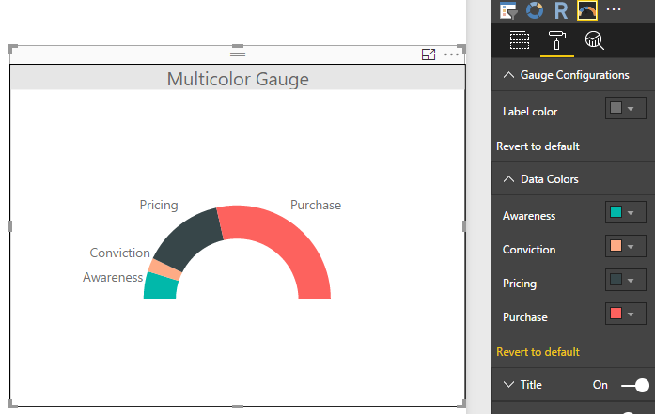

Configurations:

1. Range Values
   1. Label Color: To set label color
2. Data Colors: To set data colors for range of values